Dody Rachmat Wicaksono  
dodyrw@gmail.com, 3 Des 2010

[www.nicecoder.com](http://www.nicecoder.com)

This document is intended to be used for Indexu Deluxe 2.4

How to custom seo title url for detail page

# Detail page url

To generate detail page url, we can use <%$detail_page_url%> in rows.html or detail_rows.html file. The generated url will be constructed from the url pattern in .htaccess file.

pattern_detail: detail/{$link_id}/{$link_title}.html

To change this pattern, in admin panel > options > **mod-rewrite**.

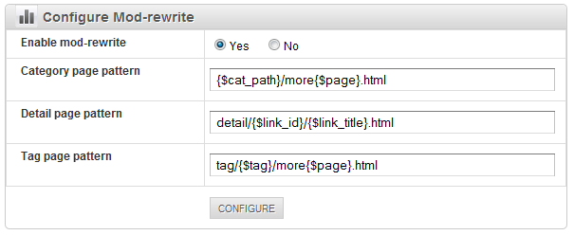

And example of generated url for above default patter is :

http://www.abcdir.com/detail/834/gamersgate.html

If you have non-english title, it also could be similar like below:

http://www.abcdir.com/detail/314/白猫.html

Above two examples may not good for seo. It would better if they will be something like:

http://www.abcdir.com/detail/834/gamersgate-buy-and-download-game-online.html

http://www.abcdir.com/detail/314/白猫-shiroi-neko-white-cat.html

In this document we will make indexu to use custom seo title instead of using title field.

# Create a new custom field for seo title

Lets create a new custom field called : seo_title

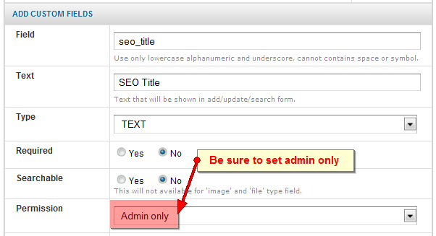

Then for each listing we will need to enter this seo_title field manually. If the seo_title is empty, then indexu will use title field.

The following is an entry to shiroi neko link.



# Hacking /lib/link.class.php

Now we need to tell indexu to use seo_title field as url. Add to line 965.

if ($seo_title) {

$title_mod = strtolower(SEOReplace($seo_title));

}

That’s it. Now the detail page url will use seo_title field. It is now point to

http://www.abcdir.com/detail/314/白猫-shiroi-neko-white-cat.html

Contributor:

* Dody Rachmat Wicaksono
* (add your name here)

If you want to contribute, feel free to fork the following github repository or email me at dodyrw@gmail.com. Thank you.

Github page:   
https://github.com/dodyrw/indexu-doc